Specifications
Nominal Voltage |  | 12 V
Capacity(10HR, 25℃) |  | 12Ah
Dimension | Length | 152±2mm (5.98inch)
Dimension | Width | 88±2mm (3.46inch)
Dimension | Height | 130±2mm (5.12inch)
Approx. Weight |  | 3.7kg (8.16lbs)±5%
Operating temperature range |  | -20℃～50℃(-4℉～122℉)
Standard Charging method  (25℃) | Current | 1.2A
Standard Charging method  (25℃) | Time | 5~10h
Quickly Charging method  (25℃) | Current | 6A
Quickly Charging method  (25℃) | Time | 1h
Terminal material |  | Lead
Container Material |  | ABS
Discharge Characteristics(25℃)
Self-discharge characteristics
Dimensions
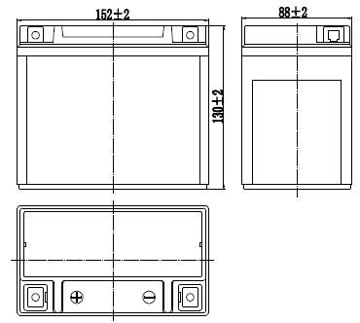

Terminal
