Specifications
Nominal Voltage |  | 12 V
Capacity(10HR, 25℃) |  | 4.5Ah
Dimension | Length | 114±2mm (4.49inch)
Dimension | Width | 70±2mm (2.76inch)
Dimension | Height | 107±2mm (4.21inch)
Approx. Weight |  | 1.8kg (3.97lbs)±5%
Operating temperature range |  | -20℃～50℃(-4℉～122℉)
Standard Charging method  (25℃) | Current | 0.5A
Standard Charging method  (25℃) | Time | 5~10h
Quickly Charging method  (25℃) | Current | 2.5A
Quickly Charging method  (25℃) | Time | 1h
Terminal material |  | Lead
Container Material |  | ABS
Discharge Characteristics(25℃)
Self-discharge characteristics
Dimensions
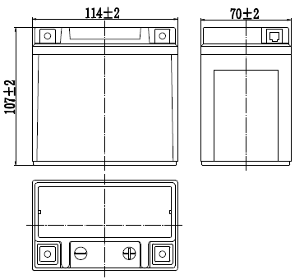

Terminal
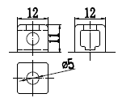
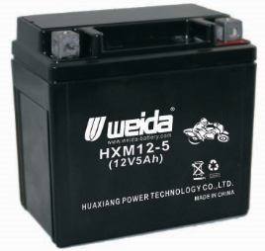

www.huaxiangbattery.com

