



3.2V 30Ah

Lithium Iron Phosphate (LiFePO4) Battery

# Product Features

Model:HZF-3.2-30-SA



**Safest LiFePo4**

cells for safe use no ﬁre no explosion

**Long Life Cycles**

>2000 cycles@0.2C,Charge/Discharge at 100%DOD

**Powerful Energy**

Quick charging,high quality and high discharge rate lithium battery cells providing more energy.

**Built-in intelligent BMS**

Over Charge **/**Discharge voltage and current protection, Short circuit protection ,Over temperature protection.

**Clean Energy**

HuaZhen Lithium Battery are the ultimate ,No toxic material ,No Pb.

Kg

2

**Light Weight**

about 40%~50%of the weight of SLA battery

**Replacement**

Replacement for SLA battery with compatible Housing

**Customized**

Battery Voltage,Capacity,Current,Size ect all can be customized to meet speciﬁc applications

# Product Description

Model #: HW-12.8V-9Ah

|  |  |  |
| --- | --- | --- |
| Electrical Characteristics | Technology | Lithium Iron Phosphate |
| Nominal Voltage | 3.65V |
| Nominal Capacity | 30Ah± [5%@0.2C](mailto:5%25@0.2C) |
| Energy | 384Wh |
| Cycle Life | 100% Depth of Discharge ~2000 cycles |
| Internal Resistance | 30mΩ |
| Self Discharge | ＜3% per month @25℃ |
| Charge | Charge mode | CC&CV(0.2C Constant current & 3.65V  Constant voltage@0.02C) |
| Max. Charge Voltage | 3.65V |
| Standard Charge Current | 6A |
| Max.Charge Current | 15A |
| Discharge | Discharge Cut-oﬀ Voltage | 2.5V |
| Standard Discharge Current | 15A |
| Max.Continuous  Discharge Current | 30A |
| Pulse Current | / |
| Operating Condition | Storage Temperature | 0℃to45℃(32℉to113℉) |
| Humidity | 60±25% |
| Charge Temperature | 0℃ to 45℃(32℉to113℉) |
| DischargeTemperature | -20℃to 45℃(32℉to113℉) |
| Structure | Water Dust Resistance | / |
| Teminal | / |
| Carrying | / |
| Case and Cover | PVC |
| Dimension（L*W*H) | 177*72*34mm |
| Weight | Approx1000g |

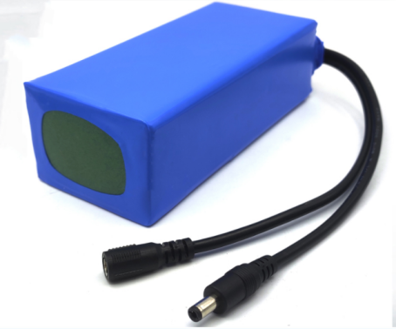

**Years limited**

**2**

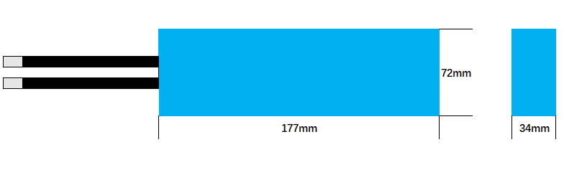

**Diﬀerent DOD Discharge Cycle Life Curve @0.5C, 25**℃

**Diﬀerent Rat**e Discharge Cu**rve @ 25**℃

110%

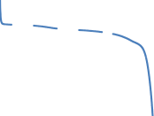

100%

**Remaining capacty(%)**

90%

80%

70%

60%

|  |  |  |  |  |  |  |  |  |  |  |  |  |  |
| --- | --- | --- | --- | --- | --- | --- | --- | --- | --- | --- | --- | --- | --- |
|  |  |  |  |  |  |  |  |  |  |  |  |  |  |
|  |  |  |  |  |  |  |  |  |  |  |  |  |  |
|  |  |  |  |  |  |  |  |  |  |  |  |  |  |
|  |  |  |  |  |  |  |  |  |  |  |  |  |  |
|  |  |  |  |  |  |  |  |  |  |  |  |  |  |
| 100%DOD 80%DOD 50%DOD | | | | | | | | | | | | | |

0 1000 2000 3000 4000 5000 6000 7000

**Numenber of Cycles**

14.0

13.5

13.0

12.5

**Voltage(V)**

12.0

11.5

11.0

10.5

10.0

|  |  |  |  |  |  |  |  |  |  |  |
| --- | --- | --- | --- | --- | --- | --- | --- | --- | --- | --- |
|  |  |  |  |  |  |  |  |  |  |  |
|  |  |  |  |  |  |  |  |  |  |  |
|  |  |  |  |  |  |  |  |  |  |  |
|  |  |  |  |  |  |  |  |  |  |  |
|  |  |  |  |  |  |  |  |  |  |  |
|  |  |  |  |  |  |  |  |  |  |  |
|  |  |  |  |  |  |  |  |  |  |  |
| 0.2C 0.5C 1C | | | | | | | |  |  |  |

0% 20% 40% 60% 80% 100%

**Capacity(%)**

Address: No.1 Huaxiang Road, Xingtai Development Zone, Changtai, Zhangzhou, Fujian, China, 363900.

E-mail: [hxpower@huaxiangbattery.com](mailto:hxpower@huaxiangbattery.com) [http://www.huaxiangbattery.com](http://www.huaxiangbattery.com/) Tel://+86-0596-8369885