Specifications
Nominal Voltage |  | 12 V
Capacity(10HR, 25℃) |  | 3Ah
Dimension | Length | 98±2mm (3.86inch)
Dimension | Width | 55±2mm (2.17inch)
Dimension | Height | 87±2mm (4.25inch)
Approx. Weight |  | 1.2kg (2.65lbs)±5%
Operating temperature range |  | -20℃～50℃(-4℉～122℉)
Standard Charging method  (25℃) | Current | 0.3A
Standard Charging method  (25℃) | Time | 5~10h
Quickly Charging method  (25℃) | Current | 1.5A
Quickly Charging method  (25℃) | Time | 1h
Terminal material |  | Lead
Container Material |  | ABS
Discharge Characteristics(25℃)
Self-discharge characteristics
Dimensions
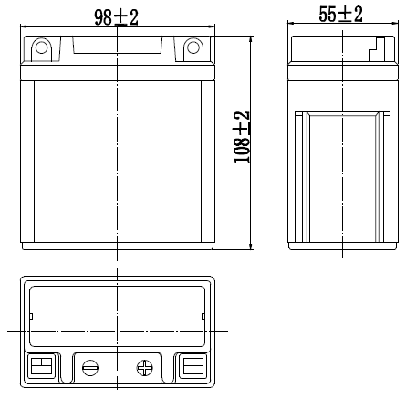

Terminal
