Specifications
Nominal Voltage |  |  | 12 V
Capacity(10HR, 25℃) |  |  | 8Ah
Dimension | Length |  | 150±2mm (5.91inch)
Dimension | Width |  | 86±2mm (3.39inch)
Dimension | Height |  | 105±2mm (4.13inch)
Approx. Weight |  |  | 2.15kg (4.74lbs)±5%
Approx.ACID Per Battery |  |  | 0.444 L
Charge Current (A |  |  | 0.8A（14.4V constant voltage charge)
Operating temperature range |  |  | -20℃～50℃  (-4℉～122℉)
Standard Charging method  (25℃) | Current |  | 0.8
Standard Charging method  (25℃) | Time |  | 5~10h
Quickly Charging method  (25℃) | Current |  | 4.0A
Quickly Charging method  (25℃) | Time |  | 1h
Cold Cranking Amperes(-18℃) |  |  | 90 A
Charge Retention (self-discharge life )  at 20℃ (68℉) |  | 3 month | 80%
 |  | 6 month | 75%
Warranty |  |  | 1year
Case Material |  |  | PP
Discharge Characteristics(25℃)

Dimensions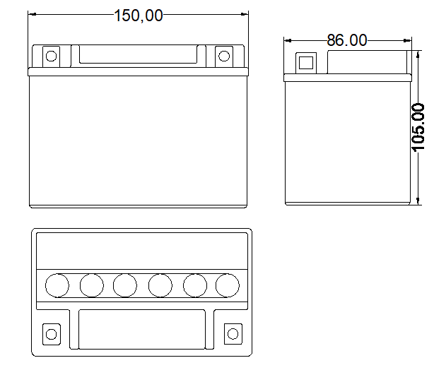
Terminal
